Lesson 2.1 Heating and cooling

Recommended teaching time for this lesson: 0.5 x 60 minute period

• 15 minutes of explicit teaching

• 15 minutes of suggested classroom activities

• 30 minutes homework

Getting started

Learning intentions & success criteria

|  |  |
| --- | --- |
| I will: | I can: |
| understand the difference between heat, energy and temperature. | * define:   + heat   + energy   + temperature (operational definition)   + thermal equilibrium. * contrast heat, energy and temperature. |

Key ideas

* Heat is the transfer of energy from a higher temperature object to a lower temperature object.
* Thermal equilibrium is achieved when two objects that are in contact with one another reach the same temperature.

Curriculum links

Advice for teaching this lesson

Things to know before you start teaching

Students often use scientific terms casually in this topic, and teachers can be guilty of this too. However, when physics teachers do this, we generally ‘know’ what we mean because of context clues, whereas students do not have this experience to help them contextualise what other people are saying. It is a good pedagogical example to try to self-correct yourself once or twice using the words incorrectly to help set up this habit for students in their future studies in physics, as it will help in situations where they have a lot of common-sense experiences.

Common misconceptions

* Students commonly state that heat is something an object has, rather than the movement of energy. Set up questions to check for this understanding.

Differentiation strategies

Have lower level students check-in with vocabulary definitions a day and a week after teaching this content to ensure the terms are still being held.

Rote practice of definitions using quizzing tools can benefit these students – as well as your core level students – extensively.

Have higher level students write the questions to practice the definitions. This benefits the higher achieving students and takes time off your shoulders.

Starter activity: How hot is it?

Approximate time: 5 minutes

**Activity placement:** Place directly above “Are heat and energy the same thing?”

**Activity summary:** A class polling activity to help students realise that it is difficult to guess temperatures, and to be exposed to data-gathering skills.

Notes for the teacher

You will need to prepare a beaker of room temperature water and a thermometer.

Call students up to feel the water and tell them to write down what they guess the temperature to be.

Make sure students are making private guesses first.

Revise the formula booklet to understand how to calculate absolute and percentage uncertainty using $∆x=\frac{\text{max }-\text{ min}}{2}$ and $\% \text{uncertainty}=\frac{∆x}{\overline{x}}$ as you can use this to help students understand how ‘spread out’ their data is.

Instructions for students

Step 1: Your teacher will have a beaker of water up the front. They will call you up to feel and guess the temperature of the water.

Step 2: When you come up to the water, do not call out your guess. Keep it private.

Step 3. Return to your desk and write down your guess. Do not try to influence the people around you – let them have their own guess.

Step 4: Provide your guess to the teacher when called upon.

* 1. When the teacher provides the answer, work out how close you were as a difference, and a percentage – these are your ‘errors’.

Helpful hints

* What is the room temperature set to? Is it air conditioned? Did you hear a weather report this morning?

Answers

<Note to production: restart numbering below at ‘a.’>

* 1. The correct answer is that the beaker and water should be about the same temperature as the room – which may very well have air conditioning. However, we feel temperature based on a difference between our nerves and whatever we touch, so this can make it difficult to know a temperature by touching alone.

Classroom activity: Vocabulary practice

Approximate time: 10 minutes

**Activity placement:** Place directly above “Skill drill – Analysing the relationship between heat and temperature change”

**Activity summary:** Utilising Frayer models to consolidate understanding of new terminology.

Notes for the teacher

A Frayer model (graphic organiser) template is needed (https://cdn.byrdseed.com/wp-content/uploads/20191113130115/byrdseed-frayer-model.pdf). These can be emailed to students, attached to your LMS or printed for hand writing.

Encourage students to use the textbook and glossary to find the relevant information.

You will need to check for ‘non-examples’ as this is often tricky. Having one or two prepared earlier will assist you.

You may prefer to supply the templates at the start and have students complete the template as you teach the terminology.

For more advanced students, you may want to suggest that they look ahead in chapters or use the glossary to find terms not explicitly introduced in this chapter.

Instructions for students

Step 1: Access four copies of the Frayer model template.

Freyer model template: <https://cdn.byrdseed.com/wp-content/uploads/20191113130115/byrdseed-frayer-model.pdf>

Step 2: Add the following terms to the middle of the templates, with one term per template.

<Note to production: restart numbering below at ‘a.’>

* 1. heat
  2. energy
  3. thermal equilibrium
  4. temperature

Step 3: Add the information in the list below to each template, in the section indicated.

* + Add the definition for the term in the upper left section.
  + Add key characteristics of the term in the upper right section.
  + Add examples of the term in the lower left section.
  + Add non-examples of the term in the lower right section.

Helpful hints

* Two of the new vocabulary terms are glossary terms.

Support activity

Step 1: Access two copies of the Frayer model template.

Step 2: Add the following terms to the middle of the templates, with one term per template.

<Note to production: restart numbering below at ‘a.’>

* 1. heat
  2. energy

Step 3: Add the information in the list below to each template, in the section indicated.

* + Add the definition for the term in the upper left section of the template. Use the glossary to help you find a definition.
  + Add key characteristics of the term in the upper right section of the template. Consider factors such as the unit, or what it causes.
  + Add examples of the term in the lower left section of the template. Where do you see heat happening in your world?
  + Add non-examples of the term in the lower right section of the template.

Challenge activity

Step 1: Access four copies of the Frayer model template.

Step 2: Add the following terms to the middle of the templates, with one term per template.

<Note to production: restart numbering below at ‘a.’>

* 1. heat
  2. energy
  3. thermal equilibrium
  4. temperature

Step 3: Add the information in the list below to each template, in the section indicated.

* + Add the definition for the term in the upper left section.
  + Add key characteristics of the term in the upper right section.
  + Add examples of the term in the lower left section.
  + Add non-examples of the term in the lower right section.

Step 4: Create a simple diagram to represent the concepts of the vocabulary words.

<Note to production: restart numbering below at ‘e.’ (not a)>

* 1. heat
  2. energy
  3. thermal equilibrium
  4. temperature

Answers

<Note to production: restart numbering below at ‘a.’ (to match the numbering for the questions above)>

* 1. Heat
     + Definition: Energy that is spontaneously transferred from one object to another due to a difference in temperature between the objects.
     + Characteristics: Movement of energy, temperature difference, unit: Joule
     + Example: A metal pan sitting on a hot stove top rising in temperature.
     + Non-example: Two objects in an air-conditioned room cooling down (the heat is between the object and the room, not the two objects).
  2. Energy
     + Definition: A measure of the ability of a system to do work and supply heat; energy is conserved in any interaction.
     + Characteristics: Ability to change things, unit: Joule
     + Example: Thermal, gravity, kinetic
     + Non-example: Forces
  3. Thermal equilibrium
     + Definition: When two objects in contact with each other reach the same temperature.
     + Characteristic: Zero net exchange, same amount of exchange between parts
     + Example: Any two objects touching each other that are not exchanging heat.
     + Non-example: Things being cooled or heated but staying the same temperature – like a car in the sun with the AC on. The car is still receiving energy in, but the AC is taking energy out. The car is not in equilibrium with its environment, but the internal environment is stable.
  4. Temperature
     + Definition: What you measure with a thermometer.
     + Characteristics: How ‘hot’ something is, a scale measurement, unit: degree Celsius
     + Example: 29 degrees Celsius, 37.5 degrees Celsius
     + Non-example: Really hot, hotter than before – any sort of colloquialism or comparative language.

Support activity

<Note to production: restart numbering below at ‘a.’ (to match the numbering for the questions above.>

* 1. Heat
     + Definition: Energy that is spontaneously transferred from one object to another due to a difference in temperature between the objects.
     + Characteristics: Movement of energy, temperature difference, unit: Joule
     + Example: A metal pan sitting on a hot stove top rising in temperature.
     + Non-example: Two objects in an air-conditioned room cooling down (the heat is between the object and the room, not the two objects).
  2. Energy
     + Definition: A measure of the ability of a system to do work and supply heat; energy is conserved in any interaction,
     + Characteristics: Ability to change things, unit: Joule
     + Example: Thermal, gravity, kinetic
     + Non-example: Forces

Challenge activity

<Note to production: restart numbering below at ‘a.’ (to match the numbering for the questions above.>

* 1. Heat
     + Definition: Energy that is spontaneously transferred from one object to another due to a difference in temperature between the objects.
     + Characteristics: Movement of energy, temperature difference, unit: Joule
     + Example: A metal pan sitting on a hot stove top rising in temperature.
     + Non-example: Two objects in an air-conditioned room cooling down (the heat is between the object and the room, not the two objects).
  2. Energy
     + Definition: A measure of the ability of a system to do work and supply heat; energy is conserved in any interaction.
     + Characteristics: Ability to change things, unit: Joule
     + Example: Thermal, gravity, kinetic
     + Non-example: Forces
  3. Thermal equilibrium
     + Definition: When two objects in contact with each other reach the same temperature.
     + Characteristic: Zero net exchange, same amount of exchange between parts
     + Example: Any two objects touching each other that are not exchanging more heat in one direction.
     + Non-example: Things being cooled or heated but staying the same temperature – like a car in the sun with the AC on. The car is still receiving energy in, but the AC is taking energy out. The car is not in equilibrium with its environment, but the internal environment is stable.
  4. Temperature
     + Definition: What you measure with a thermometer.
     + Characteristics: How ‘hot’ something is, a scale measurement, unit: degree Celsius
     + Example: 29 degrees Celsius, 37.5 degrees Celsius
     + Non-example: Really hot, hotter than before – any sort of colloquialism or comparative language
  5. Heat

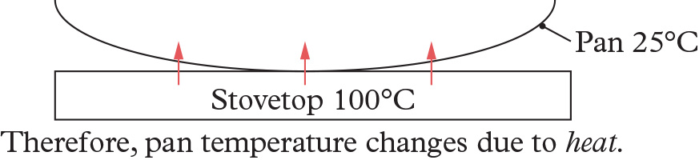

* 1. Energy

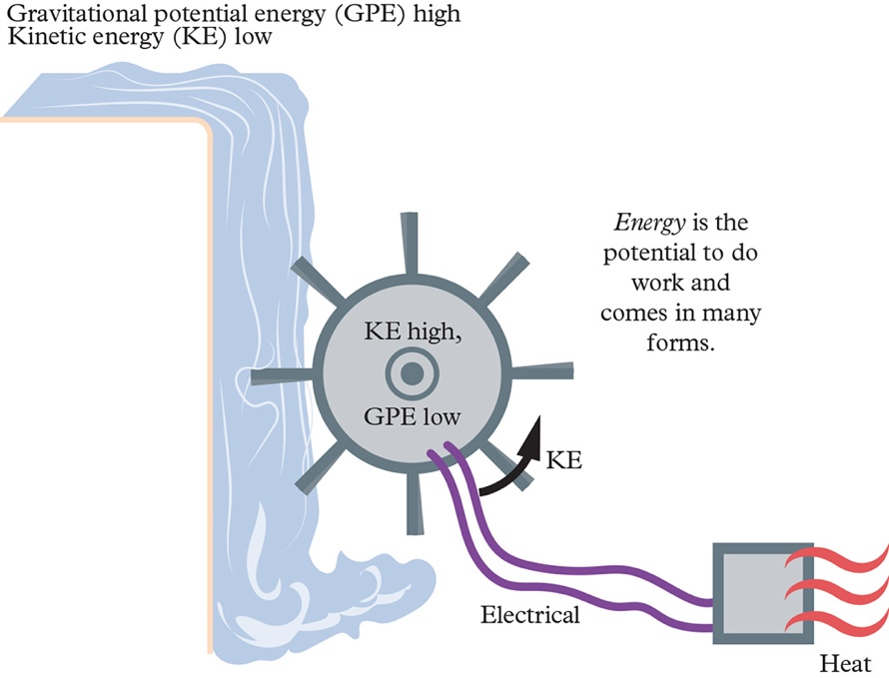

* 1. Thermal equilibrium

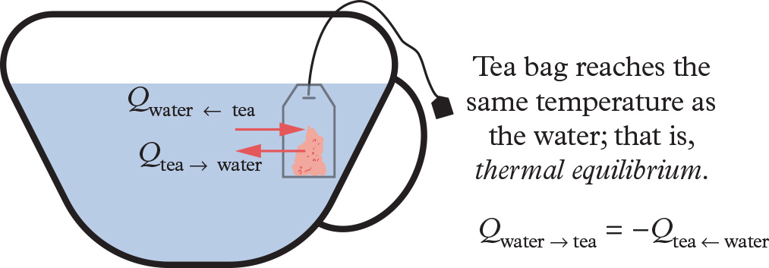

* 1. Temperature

